Introduction to Java Documentation
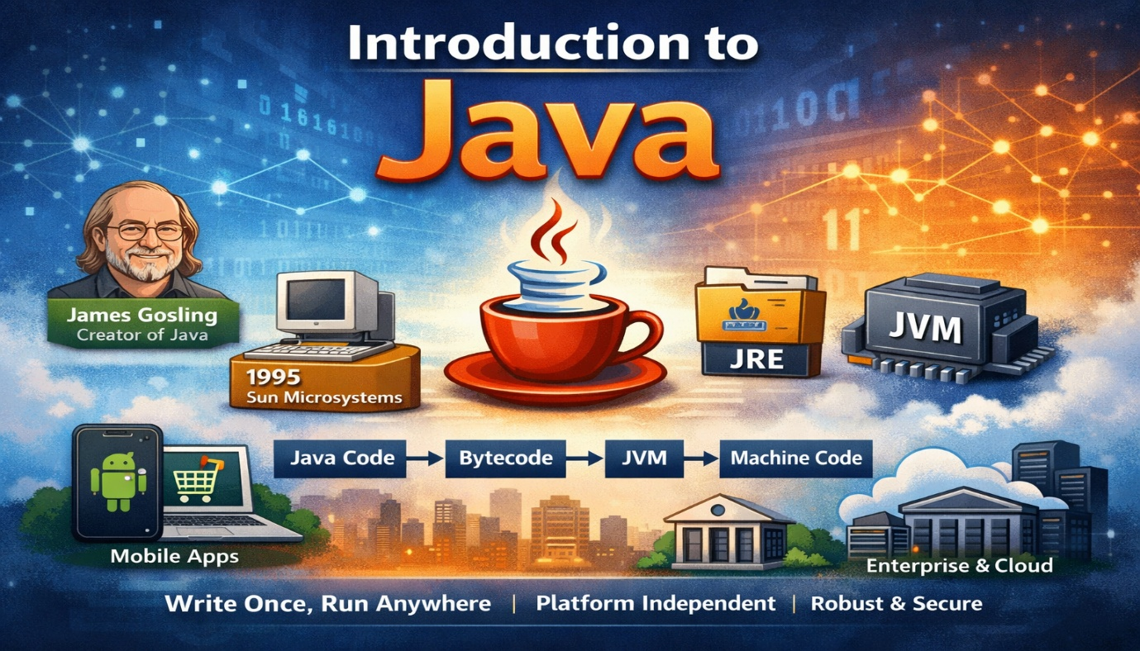

1. Introduction
Java is a high-level, object-oriented, and platform-independent programming language used for developing a wide range of applications such as web systems, mobile applications, enterprise software, and cloud services.
Java was designed with the philosophy “Write Once, Run Anywhere (WORA)”, meaning that a Java program written on one platform can run on any system that has a Java Virtual Machine (JVM).
Java programs are compiled into bytecode, which is executed by the Java Virtual Machine (JVM). This architecture allows Java programs to run on multiple operating systems without modification.
Today Java is widely used in:
- Web applications
- Android mobile applications
- Enterprise systems
- Banking and financial software
- Scientific and cloud computing

2. History of Java
2.1 The Beginning (1991)
The Java project began in June 1991 at Sun Microsystems. The project was initiated by a team of engineers including:
- James Gosling
- Mike Sheridan
- Patrick Naughton
This group of engineers became known as the Green Team.
The initial goal of the project was to develop a programming language for consumer electronic devices such as televisions and set-top boxes.
At that time, existing programming languages such as C and C++ were considered too complex and too dependent on specific hardware platforms.
The team wanted to create a language that would be:
- Simple
- Secure
- Portable
- Platform independent

2.1 The Green Project (1991)
The origin of Java began in 1991 with a research initiative at Sun Microsystems called the Green Project.
The Green Project was led by James Gosling and aimed to create a portable programming language for consumer electronics.
At that time, the team wanted to develop software that could run on devices such as:
- Television set-top boxes
- Home appliances
- Interactive television systems
The challenge was that these devices used different hardware architectures, which made it difficult to run the same software on all devices.
Existing programming languages such as C and C++ were not suitable for this purpose because they were hardware dependent.
Therefore, the team decided to develop a new programming language that could run on multiple platforms without modification.

2.3 The First Name – Oak
The programming language created during the Green Project was originally called Oak.
The name "Oak" came from the oak tree located outside the office of James Gosling at Sun Microsystems.
Oak was designed with the following key goals:
- Platform independence
- Reliability
- Security
- Simplicity
However, the name Oak could not be used commercially because it was already registered as a trademark by another company.
As a result, the team had to choose a different name for the language.

2.4 Renaming Oak to Java (1995)
During the early stages of development, the programming language created by James Gosling was originally named Oak. The name was inspired by the oak tree that stood outside Gosling’s office at Sun Microsystems. However, when the team prepared to officially release the language, they discovered that the name Oak had already been registered as a trademark by another company. Because of this legal conflict, the development team was required to choose a new name for the programming language before its public launch.
In 1995, the team organized a brainstorming session to select a unique and memorable name. Several names were suggested, but eventually the name Java was chosen. The name was inspired by Java coffee, which the developers frequently drank while working on the project. The word “Java” was considered simple, distinctive, and easy to remember, making it suitable for branding the new programming language.
After the renaming, the language was officially introduced to the public as Java, marking an important milestone in its history. Sun Microsystems promoted Java as a programming language designed for the rapidly growing internet and capable of running on multiple platforms. This renaming also helped establish a strong identity for the language, and the name Java soon became widely recognized in the software development community.

2.5 Official Release of Java (1995–1996)
The programming language Java was officially introduced to the public in 1995 by Sun Microsystems. It was presented as a programming language designed for the rapidly growing internet and capable of creating dynamic and interactive web applications.
In 1996, Sun Microsystems released the first official version of the Java Development Kit (JDK 1.0). This release included essential tools such as the Java compiler (javac), the Java Virtual Machine (JVM), and standard libraries required to develop and run Java programs.
One of the most important features introduced with Java was its platform-independent architecture, where Java programs are compiled into bytecode and executed by the JVM. This allowed Java programs to run on different operating systems without modification, following the principle “Write Once, Run Anywhere (WORA)”.
The official release of Java and the introduction of JDK 1.0 marked the beginning of Java’s widespread adoption in web development and software engineering.

2.6 Growth of Java
After its official release in 1995–1996, Java rapidly gained popularity among developers and organizations around the world. The language quickly became known for its platform independence, strong security features, and object-oriented design, which made it suitable for developing large and reliable software systems.
One of the major reasons for Java’s growth was the rapid expansion of the internet during the late 1990s. Java allowed developers to create interactive web applications using technologies such as Java Applets, which could run inside web browsers. This capability helped Java become one of the most widely discussed programming languages during the early years of the web.
During this period, Sun Microsystems continued improving the Java platform by releasing new versions with additional features and better performance. These updates expanded Java’s capabilities and allowed developers to build more complex applications.
In 1997, Sun Microsystems released JDK 1.1, which introduced several important features such as inner classes, JavaBeans, and JDBC (Java Database Connectivity). JDBC allowed Java programs to interact with databases, which made Java more suitable for building enterprise-level applications.
A major milestone came in 1998 with the release of Java 2 (J2SE 1.2). This version significantly expanded the Java platform and introduced a new structure that divided Java into three major editions:
- Java SE (Standard Edition) – for general-purpose programming
- Java EE (Enterprise Edition) – for large-scale enterprise applications
- Java ME (Micro Edition) – for embedded and mobile devices
This separation allowed Java to support a wider range of technologies and industries.
As the years progressed, Java continued to evolve with new features that improved productivity and performance. In 2004, Java 5 introduced important language features such as generics, annotations, autoboxing, and the enhanced for-loop, which made Java code easier to write and maintain.
The growth of Java accelerated even further when companies began using it for enterprise systems, banking applications, and large-scale distributed software. Java’s reliability and scalability made it a preferred choice for mission-critical applications.
In 2010, Oracle Corporation acquired Sun Microsystems and became responsible for the development and maintenance of the Java platform. Under Oracle’s leadership, Java continued to evolve with regular updates and new long-term support versions.
One of the most influential releases in modern Java development was Java 8 (2014), which introduced lambda expressions, the Stream API, and functional programming features. These additions made Java more powerful and allowed developers to write cleaner and more expressive code.
Today, Java remains one of the most widely used programming languages in the world. It is widely used for building enterprise software, Android mobile applications, web services, cloud systems, and big data platforms. The continuous improvements to the language and its large ecosystem have ensured that Java remains relevant and widely adopted in modern software development.
1998 — Java 2 (J2SE 1.2)
This release introduced major improvements and divided Java into three main editions:
- Java SE (Standard Edition)
- Java EE (Enterprise Edition)
- Java ME (Micro Edition)

2004 — Java 5
Java 5 introduced several important language features:
- Generics
- Enhanced for-loop
- Annotations
- Autoboxing and unboxing

2014 — Java 8
Java 8 introduced major functional programming features such as:
- Lambda expressions
- Stream API
- New Date and Time API
These features made Java programming more expressive and powerful
2.7 Oracle Acquisition (2010)
In 2010, Oracle Corporation acquired Sun Microsystems.
After this acquisition, Oracle became the primary steward of Java and continues to maintain and develop the Java platform today.
Oracle regularly releases new versions of Java and maintains long-term support (LTS) versions such as:
- Java 8
- Java 11
- Java 17
- Java 21
These versions provide stability and long-term support for enterprise applications.

3. Java Platform Architecture
The Java platform consists of three main components:
- Java Virtual Machine (JVM)
- Java Runtime Environment (JRE)
- Java Development Kit (JDK)
- 3.1 Java Virtual Machine (JVM)
The Java Virtual Machine (JVM) is an abstract computing machine responsible for executing Java bytecode.
When a Java program is compiled, the source code is converted into bytecode, which can be executed by the JVM on any platform.
The JVM performs several important tasks:
- Loading class files
- Verifying bytecode
- Managing memory
- Executing instructions
Because of the JVM, Java programs can run on different operating systems without modification.

- 3.2 Java Runtime Environment (JRE)
The Java Runtime Environment (JRE) provides the environment required to run Java applications.
It includes:
- The Java Virtual Machine (JVM)
- Standard class libraries
- Supporting runtime components
The JRE provides the libraries and JVM necessary to run Java applications written in the Java programming language.
Without the JRE, Java programs cannot execute.

- 3.3 Java Development Kit (JDK)
The Java Development Kit (JDK) is a complete software development kit used for developing Java applications.
The JDK includes:
- JRE
- Java compiler (javac)
- Debugging tools
- Development utilities
The JDK is therefore a superset of the JRE and contains everything required to develop and run Java programs.

4. Features of Java
Java provides several important features that contributed to its popularity.
Platform Independent
Java programs are compiled into bytecode and executed by the JVM, allowing them to run on multiple operating systems.
- Object-Oriented
Java follows the object-oriented programming paradigm, which includes:
- Classes
- Objects
- Encapsulation
- Inheritance
- Polymorphism
- Abstraction

- Secure
Java provides built-in security mechanisms such as bytecode verification and secure class loading.

- Robust
Java includes strong memory management and exception handling mechanisms.

- Multithreaded
Java supports multithreading, allowing multiple tasks to execute simultaneously.

- Portable
Java programs can be easily moved between systems without modification.

5. Conclusion
Java has evolved from a small research project in the early 1990s into one of the most widely used programming languages in the world.
Its design goals of simplicity, portability, security, and platform independence have made it a preferred choice for developers building large-scale applications.
With continuous improvements and strong community support, Java remains a powerful and reliable technology used across industries such as banking, enterprise software, mobile development, and cloud computing.

